What distinguishes a Brownfield application from a Greenfield one in terms of constraints and opportunities?
The main difference is the starting point and the constraints:
Aspect | Brownfield Application | Greenfield Application
Meaning | Modernizing or modifying an existing application | Building a new application from scratch
Constraints | Must work with existing code, databases, architecture, integrations, and business rules | Few or no legacy constraints
Technology choices | Often limited by existing technologies and dependencies | Can freely choose modern technologies and architecture
Risk | Higher risk because changes can break existing functionality | Lower legacy-related risk
Opportunities | Improve performance, security, maintainability, and gradually modernize the system | Design the system using modern architecture, cloud, microservices, etc.
Migration | Usually incremental to avoid disrupting users | No migration from an old system is required

How do business drivers such as cost reduction, agility, and compliance influence migration decisions?

Business drivers help an organization decide why, when, and how an application should be migrated.
Business Driver | Influence on Migration Decision
Cost Reduction | Organizations migrate to reduce infrastructure, maintenance, licensing, and operational costs. Cloud migration can replace expensive legacy infrastructure with scalable, pay-as-you-go resources.
Agility | Migration can help businesses release features faster, scale applications quickly, and respond to changing customer needs. Modern architectures such as microservices and cloud-native platforms support this.
Compliance | Migration decisions must ensure that data and applications continue to meet legal, regulatory, security, and industry requirements. Organizations may choose specific cloud regions, security controls, or migration strategies to maintain compliance

What is the purpose of conducting an application portfolio assessment before migration?
The purpose of an application portfolio assessment is to evaluate all existing applications before migration and decide which applications should be migrated, modernized, replaced, retired, or retained.
Key purposes:
- Understand the current environment – Identify applications, technologies, dependencies, databases, and integrations.
- Assess business value – Determine which applications are critical to business operations.
- Identify risks – Find outdated technologies, security issues, technical debt, and complex dependencies.
- Estimate migration effort and cost – Understand how difficult and expensive each application will be to migrate.
- Choose the right migration strategy – For example, rehost, replatform, refactor, replace, retain, or retire.
- Prioritize applications – Decide which applications should be migrated first based on business value, risk, and complexity.
Simple example
If a company has 100 applications, portfolio assessment helps categorize them:
- 20 → Retire because they are no longer used
- 30 → Rehost with minimal changes
- 25 → Replatform to newer technology
- 15 → Refactor/modernize
- 10 → Retain because migration is not currently beneficia

Why is mapping integration points critical during migration?
Mapping integration points means identifying all the connections an application has with other systems, databases, APIs, services, and external applications before migration.
It is critical because:
- Prevents unexpected failures – An application may depend on many other systems. Missing one integration can cause the application to stop working after migration.
- Identifies dependencies – Helps understand which applications or services must be migrated or updated together.
- Maintains data flow – Ensures data continues to move correctly between applications after migration.
- Reduces downtime – Proper planning allows integrations to be tested and switched over with minimal service interruption.
- Improves security and compliance – Helps identify where sensitive data is being transferred and ensure those connections remain secure.
- Supports testing – Teams can test APIs, databases, message queues, and other connections before going live.

How does Technical Debt impact Modernization Strategy Selection?
Technical debt refers to the accumulated cost and difficulty caused by using outdated technologies, poor design, temporary solutions, or difficult-to-maintain code.
It directly influences which modernization strategy an organization should choose.
Technical Debt Level | Suitable Strategy | Reason
Low | Rehost / Replatform | Application is relatively healthy, so major code changes may not be necessary.
Medium | Replatform / Refactor | Some components need improvement to take advantage of modern platforms.
High | Refactor / Rebuild / Replace | Legacy code may be too difficult or expensive to maintain, so deeper modernization is justified.

What are the main risks in database migration, and how can they be mitigated?
Main Risks in Database Migration and Their Mitigation
Database migration involves moving data from one database system to another. If not planned properly, it can cause data loss, downtime, security issues, or application failures.
Risk | What can happen? | Mitigation
Data loss | Some records may be missing or corrupted during migration. | Take backups, use validation checks, and perform test migrations.
Data inconsistency | Source and target databases may contain different or incorrect data. | Perform data reconciliation and compare record counts/checksums.
Downtime | The application may become unavailable during migration. | Use phased migration, replication, or a carefully planned cutover.
Schema incompatibility | Tables, data types, indexes, or constraints may not work in the new database. | Analyze and map the schemas before migration and test compatibility.
Performance issues | Queries may become slower after migration. | Benchmark the target database and optimize indexes and queries.
Security risks | Sensitive data could be exposed during transfer. | Use encryption, secure connections, access controls, and proper permissions.
Application compatibility | Applications may fail because database drivers, queries, or APIs have changed. | Test application-database integration before production cutover.
Rollback difficulties | Problems may occur after migration and returning to the old system may be difficult. | Prepare a tested rollback plan and maintain backups of the original database.

Redis – Task 1: What is Redis used for? Why?
Redis (Remote Dictionary Server) is an in-memory data store that stores data primarily in RAM. It is commonly used as a cache, database, message broker, and session store.
Why is Redis used?
- Very fast: Data is stored in memory, so read/write operations are much faster than traditional disk-based databases.
- Caching: Frequently requested data can be stored temporarily to reduce database load.
- Session management: User login/session information can be stored and accessed quickly.
- Real-time applications: Useful for chat applications, live notifications, gaming, leaderboards, etc.
- Message queues / Pub-Sub: Applications can communicate using Redis messaging features.
- Counters: Useful for page views, likes, API request counts, and similar operations.
Example:
If 10,000 users request the same product details, instead of querying the database 10,000 times, Redis can store the product data in memory and serve it quickly.

Redis – Task 2: Redis Architecture
A simplified Redis architecture looks like this:
┌───────────────────┐
│ Client Apps │
│ Web / Mobile / API│
└─────────┬─────────┘
│
│ Redis Commands
▼
┌───────────────────┐
│ Redis Server │
│ │
│ Command Handler │
│ │ │
│ ▼ │
│ In-Memory Data │
│ Store │
│ (RAM) │
└───────┬───────────┘
│
┌────────┴─────────┐
│ │
▼ ▼
┌─────────────┐ ┌──────────────┐
│ Persistence │ │ Replicas │
│ RDB / AOF │ │ (Optional) │
└─────────────┘ └──────────────┘
Main components
1. Client
The client application sends commands to Redis.
Example:
SET username "Nagur"
GET username
2. Redis Server
The Redis server receives commands, processes them, and returns the result to the client.
3. In-Memory Data Store
The primary data is kept in RAM, which is the main reason Redis is extremely fast.
Redis supports data structures such as:
- Strings
- Lists
- Sets
- Sorted Sets
- Hashes
- Streams
4. Persistence
Although Redis is primarily an in-memory store, it can persist data to disk using mechanisms such as:
- RDB (Redis Database Backup) – periodic snapshots.
- AOF (Append Only File) – records write operations.
5. Replication
Redis can maintain replicas of a primary server. Replication can improve availability and allow read workloads to be distributed.
Simple flow
Application
↓
Redis Client
↓
Redis Server
↓
RAM
↓
Data returned quickly

Redis – Task 3: Advantages and Disadvantages
Advantages
Advantage | Explanation
Very fast | Data is primarily accessed from RAM.
Low latency | Suitable for applications requiring quick responses.
Easy caching | Frequently accessed database data can be cached.
Rich data structures | Supports strings, lists, sets, hashes, sorted sets, streams, etc.
Scalable | Supports replication and Redis Cluster for scaling.
Real-time capabilities | Pub/Sub, streams, counters, and other features support real-time applications.
Persistence options | RDB and AOF can be used to preserve data.
Disadvantages
Disadvantage | Explanation
RAM cost | Storing large amounts of data in memory can be expensive.
Memory limitations | The amount of data is constrained by available memory unless data is managed carefully.
Data loss risk | Depending on the persistence configuration, data written to Redis can potentially be lost if the server fails before persistence occurs.
Not ideal for every workload | Complex relational queries and joins are better handled by relational databases such as MySQL or PostgreSQL.
Operational complexity at scale | Clustering, replication, failover, and memory management require proper configuration.
Easy way to remember
Redis = Speed + Caching + Real-time
It is often used alongside a primary database rather than replacing it.
Example architecture:
User
↓
Application
↓
Redis Cache ──→ Data found? ──→ YES → Return data
│
└── NO
↓
Database
↓
Store result in Redis
↓
Return data

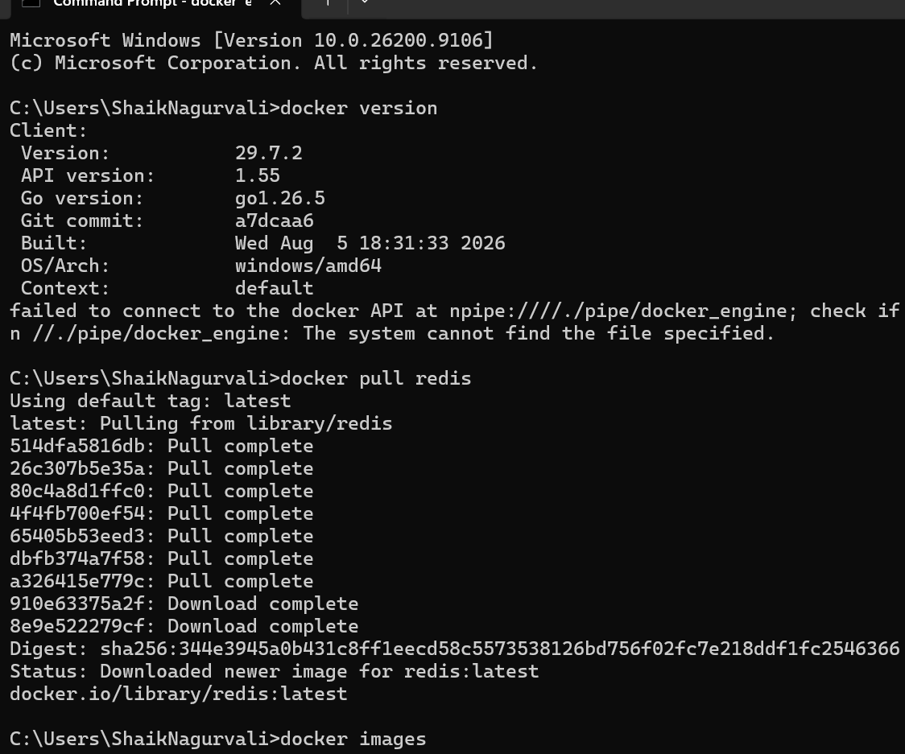

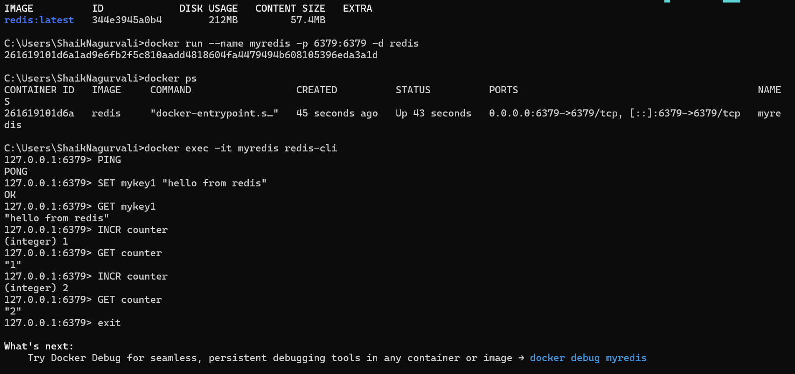
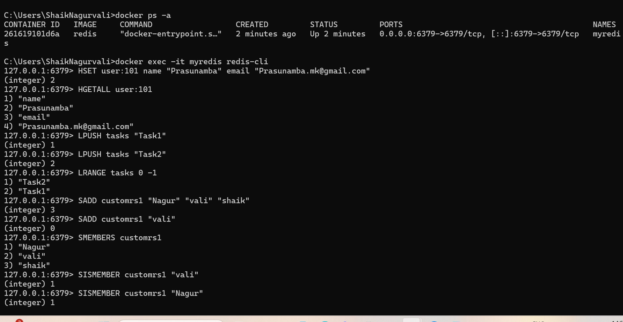

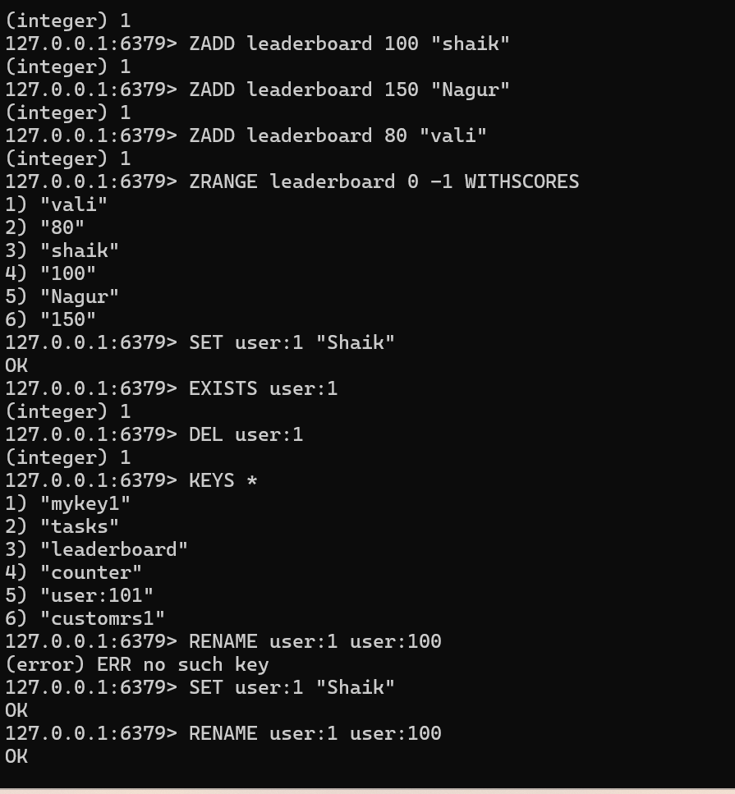

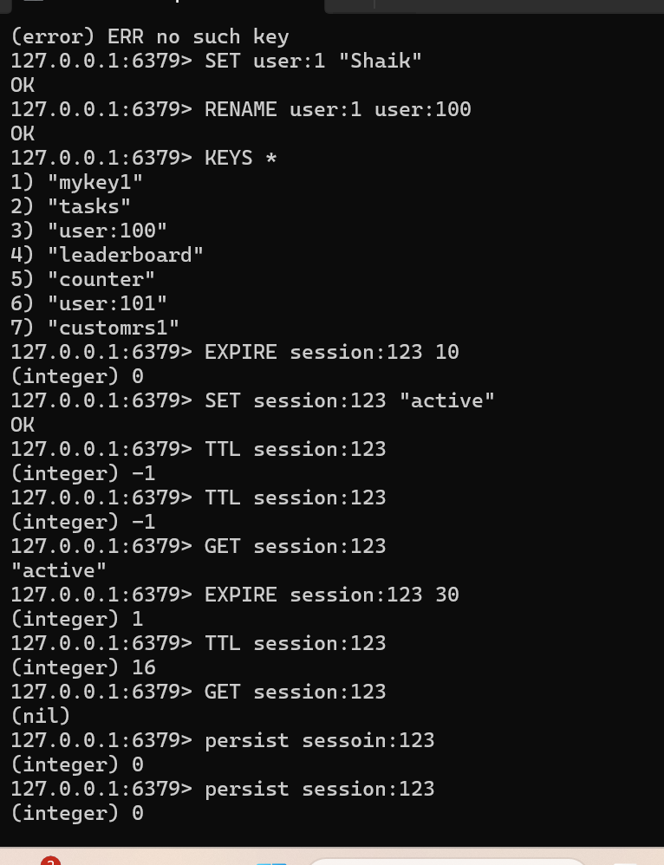

Task 17: Cache-Aside — Freshness vs Performance
Cache-Aside is a caching strategy where the application first checks the cache. If the data is not present, it gets the data from the database and then stores it in the cache.
Flow
Application
↓
Check Cache
↙ ↘
Hit Miss
↓ ↓
Return Database
data ↓
Store in Cache
How does it balance freshness and performance?
- Performance: Frequently accessed data is served from the cache, reducing database queries.
- Freshness: When data is updated, the application can invalidate or remove the old cached value so the next request gets fresh data from the database.
Risk when the database is updated frequently
If the database changes frequently, the cache can contain stale data.
For example:
Database: ₹100
Cache: ₹100

Database updated → ₹120
Cache still → ₹100
Until the cache is invalidated or expires, users may receive the old price.
In short: Cache-Aside provides good performance, but frequent database updates require effective cache invalidation to prevent stale data.

Task 18: Write-Behind vs Write-Through Caching
Write-Through
The application writes data to the cache and database synchronously.
Application
↓
Cache
↓
Database
The database is updated immediately.
Write-Behind
The application writes to the cache first, and the database is updated later/asynchronously.
Application
↓
Cache
↓
Queue/Buffer
↓
Database later
Where does Write-Behind create consistency challenges?
It is particularly risky in workloads where data must be immediately consistent, such as:
- Banking transactions
- Stock trading
- Payment processing
- Inventory management
- Financial balances
For example, if a customer's account balance changes:
Cache: ₹5,000
Database: ₹4,000
There may be a temporary inconsistency because the database hasn't received the update yet.
In short: Write-Behind provides better write performance, but it introduces a period where cache and database can contain different values. Write-Through provides stronger consistency but can have higher write latency.

Task 19: LFU vs LRU in Recommendation Systems
LRU — Least Recently Used
LRU removes the data that hasn't been accessed recently.
LFU — Least Frequently Used
LFU removes the data that is accessed the least frequently.
Why LFU can be better for recommendation systems
Recommendation systems often have popular items that users repeatedly access.
For example:
Movie A → accessed 10,000 times
Movie B → accessed 5,000 times
Movie C → accessed 2 times
Even if Movie A hasn't been accessed in the last few minutes, it may still be highly popular.
LFU keeps frequently accessed items, making it suitable for popularity-driven workloads.
LRU might remove a popular item simply because it hasn't been accessed recently.
Simple comparison
LRU → "When was it used last?"

LFU → "How often is it used?"
In short: LFU is often better when long-term popularity matters, such as recommendation systems, trending content, and frequently requested products.

Task 20: Time-Based vs Event-Based Invalidation
Cache invalidation determines when cached data should be removed or refreshed.
1. Time-Based Invalidation
The cache entry expires after a fixed period.
Example:
SET product:101 "₹100"
EXPIRE product:101 300
The data expires after 300 seconds.
Advantages
- Simple to implement.
- Predictable.
- Doesn't require an event system.
Disadvantages
- Data may become stale before the expiration time.
- If TTL is too short → more database requests.
- If TTL is too long → users may see outdated information.

2. Event-Based Invalidation
The cache is invalidated when the underlying data changes.
For example:
Database updated
↓
Update event
↓
Delete/update cache
↓
Next request gets fresh data
Advantages
- Better freshness.
- Cache can be invalidated immediately after changes.
- Good for frequently changing data.
Disadvantages
- More complex.
- Requires reliable event/message infrastructure.
- Events can potentially be lost or processed incorrectly if the system isn't designed carefully.
Comparison
Feature | Time-Based | Event-Based
Simplicity | High | Lower
Freshness | Moderate | High
Complexity | Low | High
Infrastructure | Minimal | Event system often required
Best for | Data that changes occasionally | Frequently changing data
In short:
Time-based = simpler but potentially stale.
Event-based = fresher but more complex.

Task 21: Cache Invalidation for a Real-Time Stock Trading System
A stock trading system requires very high freshness and correctness. You should not rely only on a long TTL because stock prices can change every second.
Recommended design
Stock Exchange
↓
Price Update Event
↓
Event Streaming System
↓
Redis Cluster
↓
Trading Applications
When the stock price changes:
Stock A
₹100 → ₹101
↓
Price update event
↓
Update Redis
↓
Clients receive ₹101
Cache strategy
I would use event-based invalidation/update for stock prices.
When a new market-price event arrives:
- Receive the price update.
- Validate the event.
- Update the corresponding Redis key.
- Publish the update to subscribed clients.
- Keep a persistent database/event log as the source of truth.
For example:
stock:AAPL → 195.25
stock:IBM → 241.30
Important considerations
- Use very short TTLs or no TTL for actively traded prices, depending on the architecture.
- Use event-driven updates rather than waiting for expiration.
- Maintain a persistent source of truth outside the cache.
- Handle duplicate or out-of-order events.
- Monitor Redis and the event pipeline.
- Never treat Redis alone as the authoritative record for financial transactions.
In short: A real-time trading system should prioritize freshness, ordering, reliability, and consistency, so event-based cache updates/invalidation are more appropriate than relying solely on time-based expiration.

Task 22: Redis Sharding and Scalability
Sharding means distributing data across multiple Redis nodes instead of storing everything on one server.
For example, instead of:
Redis Server
┌─────────────────┐
│ All application │
│ data │
└─────────────────┘
we can distribute it:
Redis Cluster
|
┌─────────────┼─────────────┐
↓ ↓ ↓
Node 1 Node 2 Node 3
User data Product data Session data
Redis Cluster distributes keys across hash slots, allowing different nodes to handle different portions of the data.
How does this improve scalability?
1. More memory
Instead of relying on one server's RAM:
Node 1 → 16 GB
Node 2 → 16 GB
Node 3 → 16 GB
the cluster can provide much more total memory.
2. More processing capacity
Different nodes can handle different requests simultaneously.
3. Horizontal scaling
You can add nodes as the workload grows.
More traffic
↓
Add Redis nodes
↓
More capacity

What complexity does sharding add to key management?
The main challenge is that keys are distributed across different nodes.
Applications need to understand that:
user:101 → Node 1
user:202 → Node 2
user:303 → Node 3
Redis Cluster handles much of this routing, but developers need to consider:
- Which keys belong together.
- Multi-key operations.
- Transactions involving multiple keys.
- Key distribution and hotspots.
- Resharding when nodes are added or removed.
Hash Tags
Redis provides hash tags to force related keys into the same hash slot.
For example:
user:{101}:profile
user:{101}:orders
user:{101}:cart
Because they share {101}, these keys can be placed in the same hash slot, which is useful for operations that need related keys on the same node.

